

PROJECT TITLE | School Infrastructure & Enrollment Analytics Dashboard
PROJECT CATEGORY | Education Analytics  School Analytics  Infrastructure Analytics
INSTITUTE NAME | Infinity Code Nexus
TRAINER / GUIDE | Anamania Anand Kumar
CREATED BY | Aenugula Ramcharan
TOOLS USED | Power BI Desktop Power Query, DAX & Power BI  Service
SUBMISSION DATE | [09/06/2026]

Prepared as part of the Power BI Masterclass Program to demonstrate skills in Data Analysis, Data Modeling, DAX Development, Dashboard Design, UI/UX, Storytelling, and Business Intelligence Reporting.

PROJECT OVERVIEW
==============================================================================
==========================================================

PROJECT OBJECTIVE
Develop a comprehensive Power BI dashboard to analyze school infrastructure, enrolment, teacher availability, and educational distribution across locations.
Participants are expected to:
- Analyze school infrastructure
- Evaluate Student Enrollment
- Assess teacher availability
- Compare school categories
- Generate meaningful insights & Present recommendations
================================================================ ===========

PROJECT GOAL
Convert raw school data into actionable insights that help understand educational facilities, student distribution, and school performance across different regions.

BUSINESS PROBLEM
Educational Departments and school administrators need visibility into school infrastructure, student enrollment, and resource allocation.
The objective is to identify:
- Which regions have more schools?
- Which schools have higher enrollment?
- How are teachers distributed?
- Whether infrastructure is adequate?
- How school categories vary by region?

BUSINESS QUESTIONS
================================================================
Participants must answer:
- How many schools are available?
- Which districts have more schools?
- Which school categories dominate?
- What is the total student enrollment?
- What is the teacher-to-student ratio?
- Which schools have better infrastructure?
- Which regions need improvement?

================================================================

DATASET INFORMATION
================================================================
DATASET NAME : Basic Details of Schools
DATASET DETAILS : Approximate Records 500+
Columns : 44

EXPECTED ANALYSIS AREAS
================================================================ ============
School Analytics
Enrollment Analytics
Teacher Analytics
Infrastructure Analytics
Location Analytics

POWER QUERY TRANSFORMATIONS
================================================================ ============

DATA CLEANING ACTIVITIES
- Validated Student Records
- Handled Missing Values
- Corrected Data Types
- Standardized Country Names
- Standardized Stress Level Categories
- Verified Mental Health Score Values
================================================================ ============

DATA PREPARATION ACTIVITIES
- Renamed Columns
- Replaced Blank Values
- Corrected Data Formats
- Removed Unnecessary Columns
- Validated Numerical Columns
- Prepared Data for Dashboard Analysis

CUSTOM COLUMNS CREATED
None
================================================================ ============
SCREENSHOT
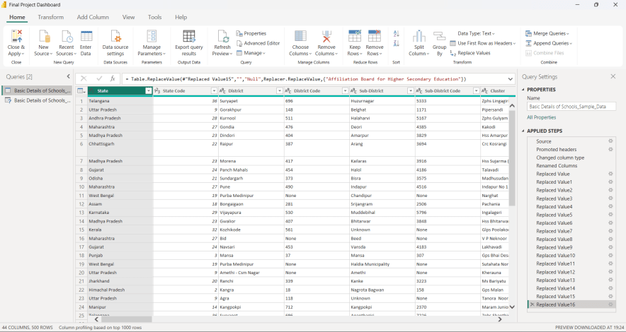

Formating Texts,Numbers,Whole Numbers and Other Areas as per required.

DATA MODELING
=================================================================== ========

Star Schema
================================================================ ============
Purpose:
The data model was designed to support well structured analysis of Student enrollment , Total Students, Total Teachers, Infrastructure Analysis, Total Classrooms, Teacher-student-ratio, Average enrollment.
================================================================ ============

MAIN TABLE
Student Social Media and Mental Health Impact Dataset
=============================================================================

KEY FIELDS
Student_ID
Country
State Name
District Name
District code
Pincode
Management
School category
Total Students
Total Teachers
Teacher-student-ratio
Infrastructure
Total Classrooms
Total Schools
Average Enrollment
Students per classrooms
Zero Teachers Schools
================================================================ ============

RELATIONSHIPS
Single Table Data Model
(No additional relationships were required because the dataset was maintained in a structured format.)
================================================================ ============

FILTER DIRECTION
Single Direction
================================================================ ============

MODEL BENEFITS
- Improved Report Performance
- Easy DAX Development
- Simplified Dashboard Design
- Efficient Data Analysis
- Better User Experience

SCREENSHOT
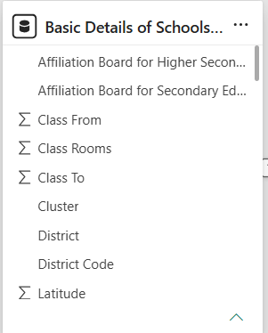

Single Table Data Model

DAX MEASURES USED
================================================================ ============

TOTAL STUDENTS
COUNTROWS('Basic Details of School_Sample_Data')
PURPOSE : Calculate the total number of students in the dataset.
================================================================ ============

AVERAGE ENROLLMENT OF STUDENTS
AVERAGE = DIVIDE ([Total Enrollment],[Total Schools])

PURPOSE : Calculate the average number of students per school.
================================================================ ============

AVERAGE('Student Social Media and Mental Health Impact'[Avg_Daily_Usage_Hours])
PURPOSE : Calculate the average number of hours students spend on social media daily.
================================================================ ============

AVERAGE CLASSROOMS
Average Classrooms = DIVIDE([Total Enrollment],[Total Classrooms])

PURPOSE : Calculate the average classrooms per school.
================================================================ ============

AVERAGE STUDENTS PER CLASSROOM
Average Students per Classroom = DIVIDE([Sum off Students],[Total Classrooms])

PURPOSE : Calculate the average number of students per classroom.
================================================================ ============

AVERAGE STUDENTS PER SCHOOL
Average Students Per-School = DIVIDE([Sum off Students],[Total Schools])

PURPOSE : To find the Average number of students per school.
================================================================ ============

AVERAGE TEACHERS PER SCHOOL
Average Teachers per school = DIVIDE([Total Teachers],[Total Schools])

PURPOSE : To find the Average number of teachers per school.

HIGHEST ENROLLMENT DISTRICT
Highest Enrollment District =
VAR DistrictTable =++
SUMMARIZE(
'Basic Details of Schools_Sample_Data',
'Basic Details of Schools_Sample_Data'[District],
"Enrollment",
SUM(
'Basic Details of Schools_Sample_Data (2)'[Total Students (class_with_pre_primary_students)]))

VAR TopDistrict =
TOPN(1, DistrictTable, [Enrollment], DESC)

RETURN
MAXX(TopDistrict,[District])
& " ("
& FORMAT(MAXX(TopDistrict,[Enrollment]),"#,##0")
& ")"
HIGHEST ENROLLMENT STATE
Highest Enrollment State =
VAR StateTable =
SUMMARIZE(
'Basic Details of Schools_Sample_Data',
'Basic Details of Schools_Sample_Data'[State],
"Enrollment",
SUM(
'Basic Details of Schools_Sample_Data (2)'[Total Students (class_with_pre_primary_students)]))

VAR TopState =
TOPN(1, StateTable, [Enrollment], DESC)

RETURN
MAXX(TopState,[State])
& " ("
& FORMAT(MAXX(TopState,[Enrollment]),"#,##0")
& ")
=====================================================================
SINGLE CLASSROOMS
Single Classrooms = CALCULATE(DISTINCTCOUNT('Basic Details of Schools_Sample_Data (2)'[School Code (udise_school_code)]),'Basic Details of Schools_Sample_Data (2)'[Class Rooms (class_rooms)]=1)
STUDENTS PER-CLASSROOMS
Students per Classroom = DIVIDE([Total Enrollment],[Total Classrooms])
======================================================================
SUM OFF STUDENTS
Sum off Students = SUM('Basic Details of Schools_Sample_Data (2)'[Total Students (class_with_pre_primary_students)])
======================================================================
TEACHER-STUDENT-RATIO
Teacher-Student Ratio = DIVIDE(SUM('Basic Details of Schools_Sample_Data (2)'[Total Students (class_with_pre_primary_students)]),SUM('Basic Details of Schools_Sample_Data (2)'[Teachers (total_teachers)]))
======================================================================
TOTAL CLASSROOMS
Total Classrooms = SUM('Basic Details of Schools_Sample_Data (2)'[Class Rooms (class_rooms)])
======================================================================

TOTAL SCHOOLS
Total Schools = DISTINCTCOUNT('Basic Details of Schools_Sample_Data (2)'[School Code (udise_school_code)])
=========================================================================
TOTAL TEACHERS
Total Teachers = SUM('Basic Details of Schools_Sample_Data (2)'[Teachers (total_teachers)]

VISUALIZATIONS USED
================================================================ ============

KPI CARDS
Purpose: Display key business metrics such as Total Students, Total teachers, Total Classrooms, Total Schools, Teacher-student-ratio.
KPIs Included:
- Total Teachers
- Total Classrooms
- Total Schools
- Average Teachers per school
- Average Students per classroom
- Average Students per-school
- Average Enrolment
- Teacher-student-ratio
- Total Enrolment
- Highest Enrolment state
- Largest Enrolment School
- Zero Teachers Schools
- Single Classrooms Schools
- Average Classrooms
- Total Students per classrooms

SCREENSHOT

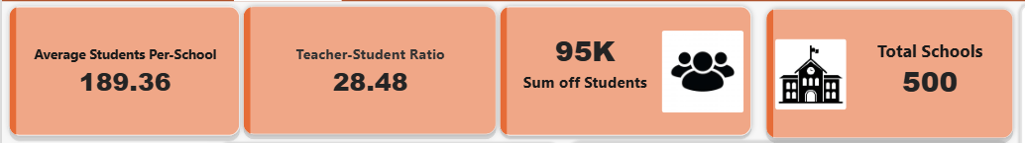

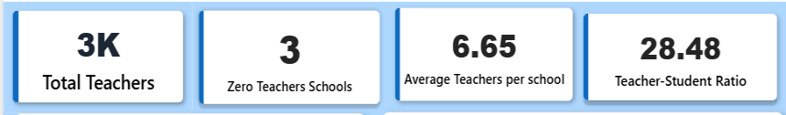

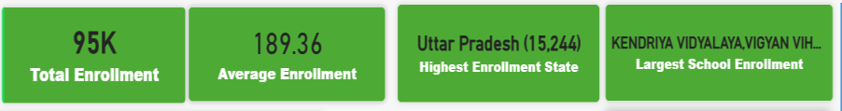

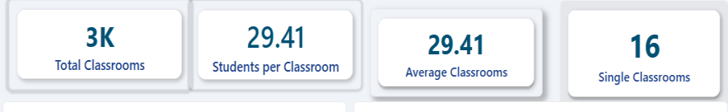

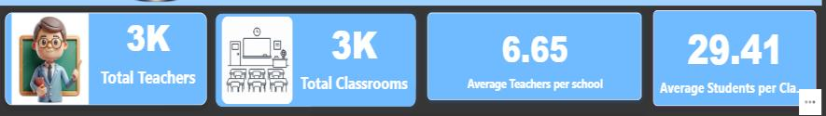

=============================================================================

CLUSTERED BAR CHART
Purpose: To compare values across different categories and multiple groups side by side, making it easy to identify differences and patterns
The charts were used to analyze:
- Total Teachers by District wise
- Total Students by state wise
- Top 10 States of Teachers
- Total Enrollment by School category
- Total Classrooms by School name
These visualizations help compare Teachers distribution across the districts and students distribution across the state and Total Students by school category and Top 10 states of Teachers indicating the positive result and infrastructure(classrooms) by school name.

SCREENSHOT
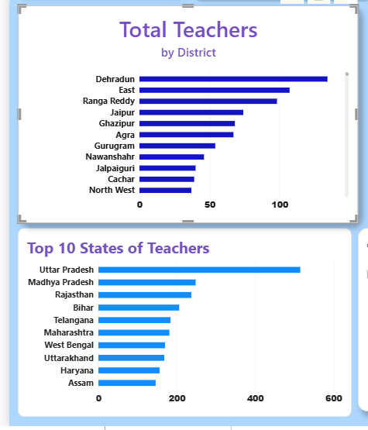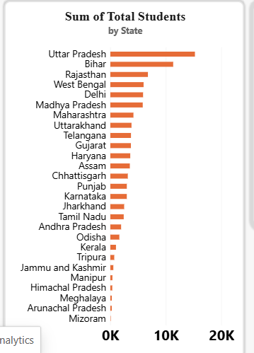

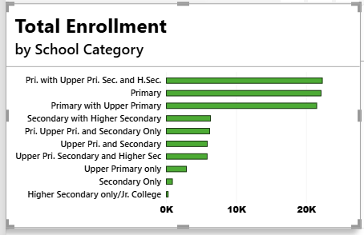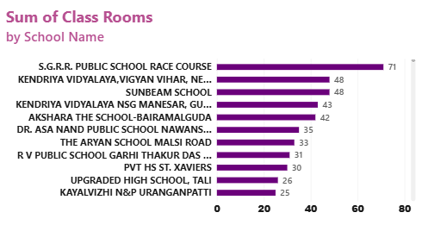

================================================================ ============

CLUSTERED COLUMN CHART
Purpose: The Clustered Column Chart is used to compare values across different categories by displaying multiple data series side by side. It helps identify trends, variations, and performance differences among categories, making data analysis and comparison easier and more effective Average Mental Health Score by Country
- Top 10 States of Total Classrooms
- Teacher-Student Ratio
- Total Teachers by state
- Total Enrollment
These visualizations help compare Teacher-student-ratio by Management type , Total Enrollment by school type, Total Teachers by state and Top 10 States of Total Classrooms

SCREENSHOT
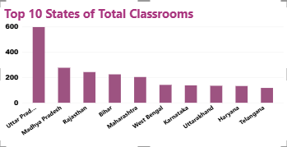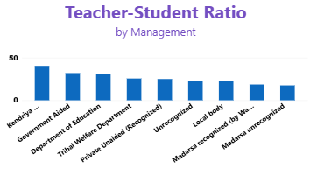
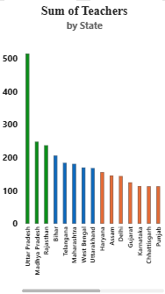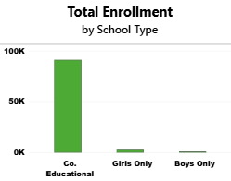
================================================================ ===================

PIE CHART
Purpose: The Pie Chart is used to represent the proportion of each category as a part of the whole dataset. It helps in understanding percentage distribution and comparing the contribution of different categories at a glance.
The charts were used to analyze:
- Total Schools by Management
- Total Teachers by School category
These visualizations help identify dominant Schools by management type and proportion of Total Schools across the pie chart and Total teachers by school category.

SCREENSHOT

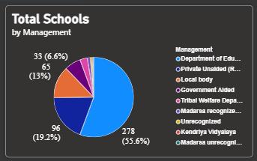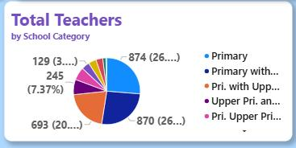

================================================================

TABLE / MATRIX
Purpose: The Table/Matrix visual is used to display detailed data in a structured tabular format, allowing users to view and analyze individual records and aggregated values. It helps in comparing multiple measures across categories and supports hierarchical data analysis with drill-down capabilities.
The visuals were used to analyze:
- Detailed Analysis of School Infrastructure.
- With the total classrooms , total teachers, total schools.
- Detailed Analysis of Student Enrollment analysis.
- With Total Schools, total Students, Total Teachers.

These visualizations provide structured insights, support the business analysis and detailed analysis of weak areas and strong areas in the and support the decision making for professionals.

SCREENSHOT
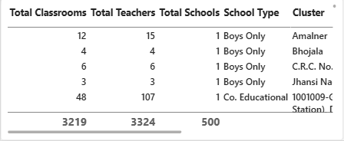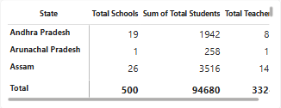
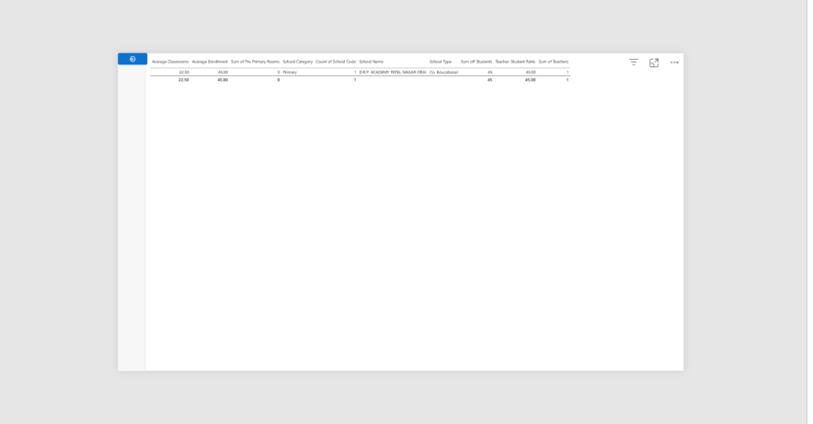

================================================================ ============

SLICERS
Purpose: he Slicer visual is used to filter data interactively across all visuals in a report. It enables users to focus on specific categories, regions, dates, or other criteria, making data analysis more dynamic and user-friendly

State Slicer
- Enables State-wise analysis of Total Students , Total teachers and the count of school code.
District Slicer
- Enables users to view and analyze data for a particular district within a selected state.
Management Slicer
- Filters schools and related metrics according to the type of school management.
School Name Slicer
- Allows users to focus on the performance and details of a specific school.
Class Room Slicer
- Used to filter schools based on the number of available classrooms for infrastructure analysis.
Enrolment Slicer
- Enables analysis of schools based on student enrolment levels.
Teachers Slicer
- Filters data according to the number of teachers available in schools.

School Category Slicer
- Allows users to analyze data for specific categories or levels of schools.
Infrastructure Slicer
- Helps users focus on schools with particular infrastructure facilities and resources.
Academic Slicer
- Filters dashboard insights based on the selected academic year for trend analysis.

SCREENSHOTS

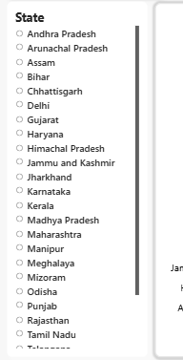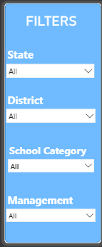

DASHBOARD SCREENSHOTS

EXECUTIVE DASHBOARD
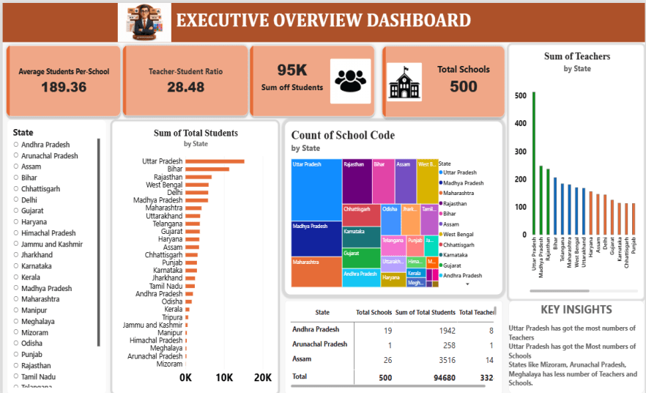

Explanation

The Executive Overview Dashboard provides a comprehensive summary of school performance, student enrollment, teacher availability, and school distribution across different states. It presents key performance indicators such as Total Students, Total Schools, Average Students per School, and Teacher-Student Ratio, enabling stakeholders to evaluate the overall educational landscape efficiently. Through interactive filters and visualizations, the dashboard helps educational administrators identify trends, compare state-wise performance, and make informed decisions regarding resource allocation and school management.
Key Insights
• Total Students enrolled across all schools: 94,680.
• Total Schools analyzed: 500.
• Average Students per School: 189.36.
• Teacher-Student Ratio: 28.48, indicating the average number of students served by each teacher.
• Uttar Pradesh has the highest student enrollment among all states.
• Uttar Pradesh also has the highest number of schools and teachers in the dataset.
• States such as Mizoram, Meghalaya, and Arunachal Pradesh have comparatively fewer schools and teachers.

SCHOOL ANALYTICS DASHBOARD

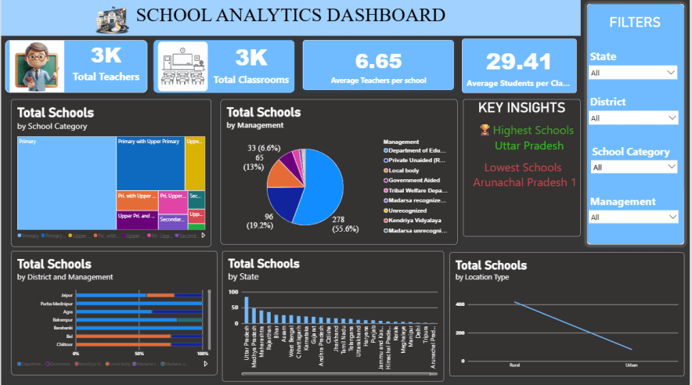

Explanation
The School Analytics Dashboard provides an overview of school infrastructure, teacher availability, and school distribution across different regions. It highlights key metrics such as Total Teachers, Total Classrooms, Average Teachers per School, and Average Students per Classroom, helping stakeholders make informed decisions through interactive analysis.
Key Insights
• Total Teachers: 3K
• Total Classrooms: 3K
• Average Teachers per School: 6.65
• Average Students per Classroom: 29.41
• Uttar Pradesh has the highest number of schools.
• Arunachal Pradesh has the lowest number of schools.
• Primary schools form the largest school category.
• Rural areas have more schools than urban areas.
• Interactive filters enable detailed state-wise and district-wise analysis.

SCHOOL ENROLLMENT DASHBOARD

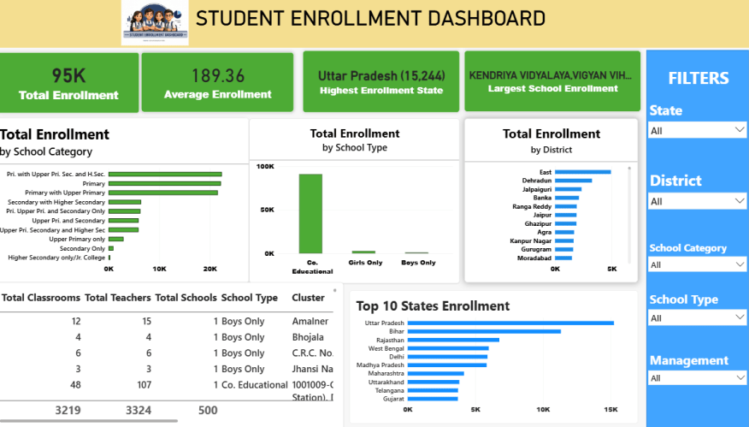

Explanation

The Student Enrollment Dashboard provides a comprehensive view of student enrollment across schools, states, districts, and school categories. It highlights key enrollment metrics and trends, enabling stakeholders to analyze student distribution and identify regions or institutions with high and low enrollment levels through interactive filters and visualizations.
Key Insights
• Total Student Enrollment: 95K
• Average Enrollment per School: 189.36
• Uttar Pradesh has the highest enrollment with 15,244 students.
• Kendriya Vidyalaya, Vigyan Vihar has the largest school enrollment.
• Co-Educational schools account for the majority of student enrollment.
• Primary and Upper Primary categories contribute the highest share of enrollments.
• Enrollment distribution varies significantly across states and districts.
• Interactive filters enable detailed analysis by State, District, School Category, School Type, and Management.

TEACHER ANALYTICS DASHBOARD

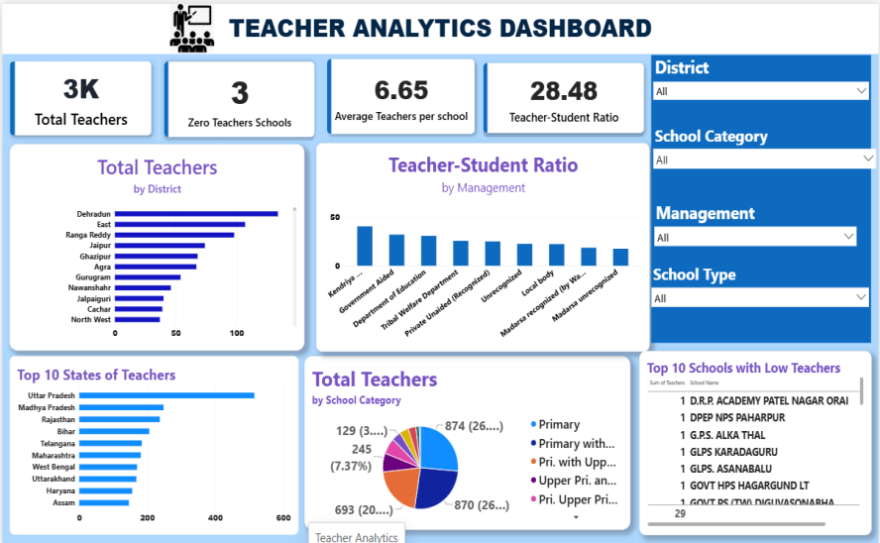

Explanation

The Teacher Analytics Dashboard provides a comprehensive overview of teacher distribution, teacher-student ratios, and staffing patterns across schools. It highlights key metrics such as Total Teachers, Zero-Teacher Schools, Average Teachers per School, and Teacher-Student Ratio, enabling stakeholders to assess teacher availability and identify areas requiring attention.

Key Insights

• Total Teachers across all schools: 3K
• Only 3 schools have zero teachers.
• Average Teachers per School: 6.65
• Teacher-Student Ratio: 28.48
• Uttar Pradesh has the highest number of teachers among all states.
• Teacher distribution varies significantly across districts and school categories.
• Primary schools account for the largest share of teachers.
• Interactive filters support detailed analysis by District, School Category, Management, and School Type.

SCHOOL INFRASTRUUCTURE ANALYTICS DASHBOARD

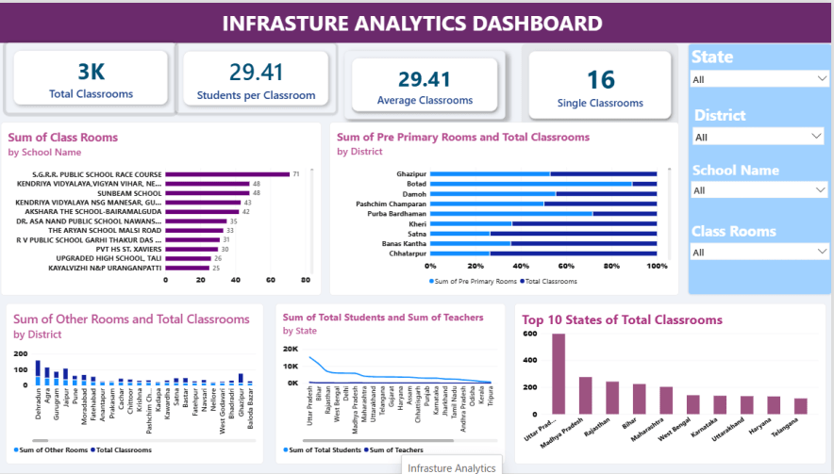

Explanation

The Infrastructure Analytics Dashboard provides a comprehensive overview of classroom availability and school infrastructure across different regions. It highlights key metrics such as Total Classrooms, Students per Classroom, Average Classrooms, and Single Classrooms, enabling stakeholders to assess infrastructure capacity and identify areas requiring improvement through interactive analysis.

Key Insights

• Total Classrooms available across all schools: 3K.
• Average Students per Classroom: 29.41.
• Average Classrooms per School: 29.41.
• Only 16 schools operate with a single classroom.
• Uttar Pradesh has the highest number of classrooms among all states.
• Classroom distribution varies significantly across districts and schools.
• Some schools have substantially higher classroom capacity, indicating better infrastructure availability.
• Interactive filters enable detailed analysis by State, District, School Name, and Classroom count.

KEY INSIGHTS
================================================================ =============
INSIGHT-1
The dataset consists of 500 schools with a total student enrollment of approximately 95K students, providing a comprehensive view of the educational ecosystem.
INSIGHT-2
A total of 3K teachers support the student population, resulting in an overall Teacher-Student Ratio of 28.48 and an average of 6.65 teachers per school.
INSIGHT-3
The education infrastructure includes approximately 3K classrooms, with an average of 29.41 students per classroom, indicating efficient classroom utilization.
INSIGHT-4
Uttar Pradesh consistently ranks highest in terms of schools, student enrollment, teachers, and classrooms, making it the most significant contributor in the dataset.
INSIGHT-5
Primary and Upper Primary schools account for the largest share of schools, teachers, and student enrollment across all school categories.
INSIGHT-6
Co-Educational institutions represent the majority of student enrollment, highlighting their dominant role in the education system.
INSIGHT-7
Rural areas contain a higher concentration of schools compared to urban areas, demonstrating broader educational coverage in rural regions.
INSIGHT-8
Only a small number of schools face infrastructure and staffing challenges, with 16 single-classroom schools and 3 schools without teachers.
INSIGHT-9
Significant variations exist across states and districts in terms of enrollment, teacher distribution, and infrastructure availability, indicating regional disparities in educational resources.
INSIGHT-10
The interactive dashboards enable stakeholders to monitor school performance, identify resource gaps, and support data-driven educational planning and decision-making.

BUSINESS RECOMMENDATIONS
================================================================ ============

RECOMMENDATION-1
Educational authorities should prioritize teacher recruitment and equitable distribution to improve the Teacher-Student Ratio and ensure quality education across all regions.
RECOMMENDATION-2
States and districts with lower school counts, teacher availability, and infrastructure resources should receive targeted investments to reduce regional disparities.
RECOMMENDATION-3
Schools operating with limited classroom infrastructure, including single-classroom schools, should be upgraded to improve learning environments and accommodate future enrollment growth.
RECOMMENDATION-4
Regular monitoring of student enrollment trends should be conducted to ensure adequate allocation of teachers, classrooms, and educational resources.
RECOMMENDATION-5
Special attention should be given to schools with low teacher strength or staffing shortages to maintain effective classroom management and educational outcomes.
RECOMMENDATION-6
Infrastructure development programs should focus on increasing classroom capacity and improving school facilities in high-enrollment regions.
RECOMMENDATION-7
Schools with exceptionally high student enrollment should be provided with additional teachers and classrooms to prevent overcrowding and maintain educational quality.
RECOMMENDATION-8
Regions with low school availability should be prioritized for new school establishment and infrastructure expansion to improve access to education and ensure balanced regional development.

FEATURES IMPLEMENTED
================================================================ ============
- Drill Down
- Drill Up
- Drill Through
- Tooltips
- Slicers
- Conditional Formatting
- Custom Theme

CHALLENGES FACED
================================================================ ============
Conditional Formatting
DAX Calculations and formulas
Dashboard Layout Design
Drill Up and Drill down

LEARNINGS
================================================================ ============
Power Query
Data Modeling
DAX Development
Dashboard Design
Storytelling
Business Analysis

PROJECT STORYTELLING
================================================================ ============

BUSINESS SCENARIO
Educational institutions generate vast amounts of data related to student enrollment, teacher availability, school infrastructure, and educational resources across different regions. However, administrators and policymakers often face challenges in analyzing this data effectively to identify resource gaps, monitor school performance, and make informed decisions.
This project aims to transform educational data into interactive and insightful dashboards that provide a comprehensive view of school operations, student distribution, teacher allocation, and infrastructure availability. Through data visualization and analytics, the project enables stakeholders to identify regional disparities, optimize resource allocation, improve educational planning, and support data-driven decision-making for enhancing the overall quality of education.
The solution consists of five dashboards—Executive Overview, School Analytics, Student Enrollment Analytics, Teacher Analytics, and Infrastructure Analytics—which together provide a holistic understanding of the educational ecosystem and help drive strategic improvements across schools and regions.

BUSINESS PROBLEM
● How are students, teachers, and schools distributed across different states and districts?
● Which states have the highest and lowest student enrollment levels?
● How effectively are teachers allocated across schools, and are there any staffing gaps?
● What is the average Teacher-Student Ratio, and how does it vary across regions?
● Which schools and states have the highest concentration of educational resources?
● How adequate is the classroom infrastructure in supporting current student enrollment levels?
● Are there significant regional disparities in school infrastructure, teacher availability, and student enrollment?
● Which school categories and management types contribute the most to the overall education system?
● How can educational authorities optimize resource allocation to improve school performance and educational accessibility?
● What strategic actions can be taken to strengthen educational infrastructure, teacher distribution, and student outcomes across regions?

ANALYSIS APPROACH
● Analyzed student enrollment patterns across schools, districts, and states to understand educational coverage and distribution.
● Evaluated teacher availability, teacher allocation, and Teacher-Student Ratios across different regions and school categories.
● Assessed classroom infrastructure, including classroom availability, capacity utilization, and infrastructure adequacy.
● Compared school distribution across management types, school categories, and location types (Rural and Urban).
● Identified regional disparities in student enrollment, teacher strength, and infrastructure resources across states and districts.
● Analyzed school performance indicators using key metrics such as Total Students, Total Schools, Total Teachers, and Average Students per Classroom.
● Developed interactive dashboards using KPIs, Drill Down, Conditional Formatting, Bookmarks, Tooltips, and Slicers to enable dynamic and detailed educational analysis

KEY FINDINGS
================================================================ ============
• The dataset consists of 500 schools with approximately 95K students, providing a comprehensive view of educational resources and student distribution across multiple regions.
• Uttar Pradesh recorded the highest number of schools, student enrollments, teachers, and classrooms, indicating a strong concentration of educational resources within the state.
• The average school accommodates 189.36 students, reflecting the overall enrollment capacity of institutions included in the dataset.
• The overall Teacher-Student Ratio is 28.48, providing insight into teacher availability and student support across schools.
• Schools have an average of 6.65 teachers, highlighting variations in staffing levels among institutions.
• The education system includes approximately 3K classrooms, with an average of 29.41 students per classroom, reflecting classroom utilization patterns.
• Primary and Upper Primary schools account for the largest share of schools, students, and teachers, emphasizing the importance of foundational education within the system.
• Rural areas contain a higher concentration of schools than urban areas, demonstrating wider educational coverage in rural regions.
• Noticeable differences exist across states and districts in terms of enrollment, teacher allocation, and infrastructure availability, indicating variations in educational resource distribution.
• A small number of schools operate with limited classroom infrastructure or teacher availability, highlighting areas that may require additional educational support and resource allocation.
• The analysis reveals that educational resources are not distributed uniformly across all regions, creating opportunities for targeted planning and infrastructure development.

================================================================ ============

BUSINESS IMPACT
================================================================ ============
• Supports data-driven decision-making for educational administrators, policymakers, and school management authorities.
• Enables effective monitoring of student enrollment, teacher allocation, and school infrastructure across different regions.
• Helps identify gaps in educational resources, including staffing shortages and infrastructure limitations.
• Facilitates better planning and allocation of teachers, classrooms, and other educational resources.
• Assists in evaluating state-wise and district-wise educational performance and resource distribution.
• Supports infrastructure development initiatives by highlighting schools and regions requiring additional facilities.
• Promotes equitable access to education through the identification of regional disparities in schools, teachers, and classrooms.
• Provides actionable insights that help improve educational planning, resource utilization, and overall school performance.

PROJECT DEPLOYMENT
===============================================================================
DEPLOYMENT OBJECTIVE
Deploy the Power BI School Analytics solution to provide educational administrators and stakeholders with interactive dashboards for monitoring student enrollment, teacher distribution, school performance, and infrastructure availability in real time.
DEPLOYMENT PLATFORM
Power BI Service
DEPLOYMENT PROCESS
Power BI Service
STEP-1
Validate data quality, data model relationships, and DAX measures in Power BI Desktop.
STEP-2
Optimize dashboard design, visual performance, navigation, and user experience across all five analytical dashboards.
STEP-3
Publish the PBIX file to Power BI Service.
STEP-4
Configure dataset refresh settings to ensure dashboards reflect the latest educational data.
STEP-5
Create and organize dashboards from the published reports for Executive, School, Enrollment, Teacher, and Infrastructure Analytics.
STEP-6
Apply role-based security and access permissions to protect educational data and control user access.
STEP-7
Share dashboards with educational administrators, policymakers, and other authorized stakeholders for data-driven decision-making.

BUSINESS BENEFITS
• Centralized School Analytics Platform
• Interactive Dashboard Reporting
• Improved Student Enrollment Monitoring
• Enhanced Teacher Allocation Analysis
• Better Infrastructure Planning and Resource Management
• Faster Data-Driven Decision Making
• Improved Educational Resource Utilization
• State-wise and District-wise Performance Analysis
• Identification of Staffing and Infrastructure Gaps
• Support for Educational Planning and Policy Development
• Enhanced School Performance Monitoring
• Actionable Insights for Improving Educational Outcomes

CONCLUSION
================================================================ ============
The School Analytics Dashboard Project successfully transformed raw educational data into meaningful insights through a comprehensive suite of interactive Power BI dashboards. By analyzing key aspects such as student enrollment, teacher distribution, school infrastructure, and educational resource allocation, the project provided a holistic view of the educational ecosystem across multiple states and districts.
The analysis revealed significant variations in enrollment levels, teacher availability, classroom capacity, and school distribution, helping identify both strengths and areas requiring improvement. The project highlighted the importance of balanced resource allocation, adequate staffing, and infrastructure development in ensuring equitable access to quality education. Additionally, state-wise and district-wise comparisons enabled a deeper understanding of regional disparities and educational performance patterns.
Overall, the project serves as a valuable decision-support solution for educational administrators, policymakers, and school management authorities. By enabling data-driven planning, resource optimization, and performance monitoring, the dashboard supports informed decision-making and contributes to improving educational effectiveness, strengthening infrastructure planning, and promoting long-term educational development.

